Driver Anti Sleep Device Project

In modern-times, owing to hectic schedules it becomes very difficult to remain active all the time. Imagine a situation where a person is driving home from work, dead tired after facing all the challenges of the day. His hands are on the wheel and foot on the pedal but suddenly he starts feeling drowsy, his eyes start shutting and his vision blurs and before he knows it, he’s asleep. Falling asleep on the wheel can lead to serious consequences, there may be accidents and people may even lose their lives. This situation is much more common then we notice and hence, it is very important to counter this problem. So to address this issue, we have come up with a Driver Anti-sleep Device. This system alerts the user if he/she falls asleep at the wheel thereby, avoiding accidents and saving lives. This system is useful especially for people who travel long distances and people who are driving late at night. The circuit is built using 555 timer IC as switch, transistor, a relay and a tilt sensor. Whenever the driver feels sleepy and bends his neck down the tilt sensor detects and transistor drive the buzzer to sound an intermediate beep... and leds start glowing. When driver comes back to his normal position tilt sensor senses that and buzzer and leds gets switch off.

Block Diagram:
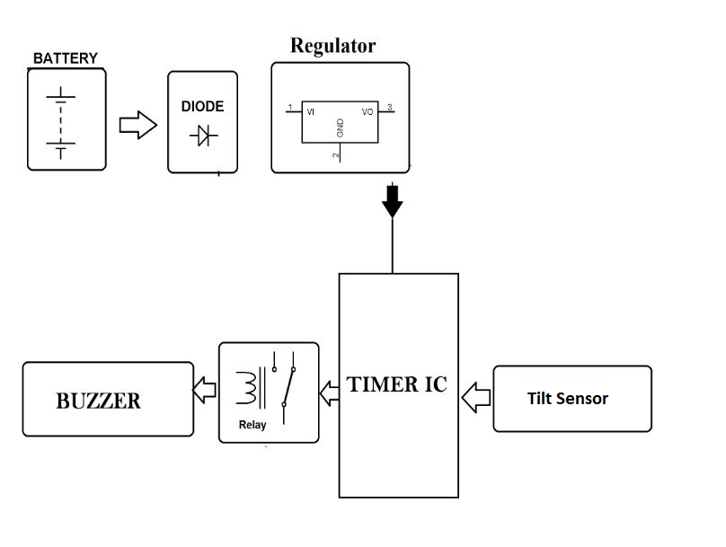

Hardware Specifications
- 555 Timer IC
- Tilt sensor
- Resistors
- Capacitors
- Buzzer-
- Cables & Connectors
- Diodes
- PCB
- LED’s
- Switch
- Relay

